Preventing Anxiety-Based School Refusal

A guide to early intervention
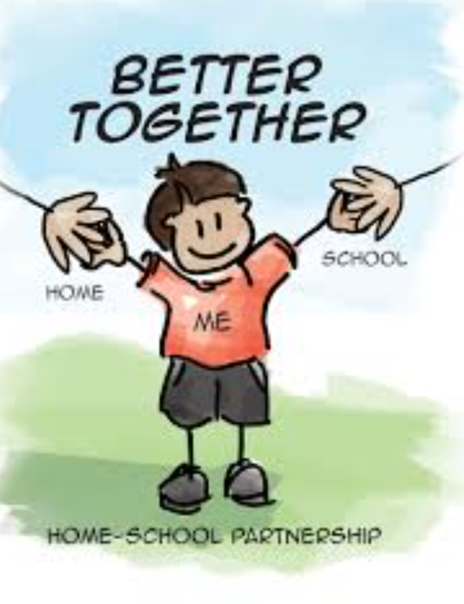

Guidance for children and young people

How to manage worries and anxiety – some tips for young people

We all experience anxiety - your teachers, your parents, others young people – it’s a normal human feeling. What matters most is how it’s managed, so it doesn’t get in the way of you living your life to the full. Here are some tips to help you with that.

The fact that you have this guidance shows that your teachers really want to support you through this. You are not on your own. If you can tell us what will help, then things can be put in place or issues resolved so that school feels like a safer place.

- Face your fears!
Avoiding situations that make us feel frightened is natural but it makes the fear worse. This is because we never learn that those things we fear actually are okay and don’t cause us any harm.

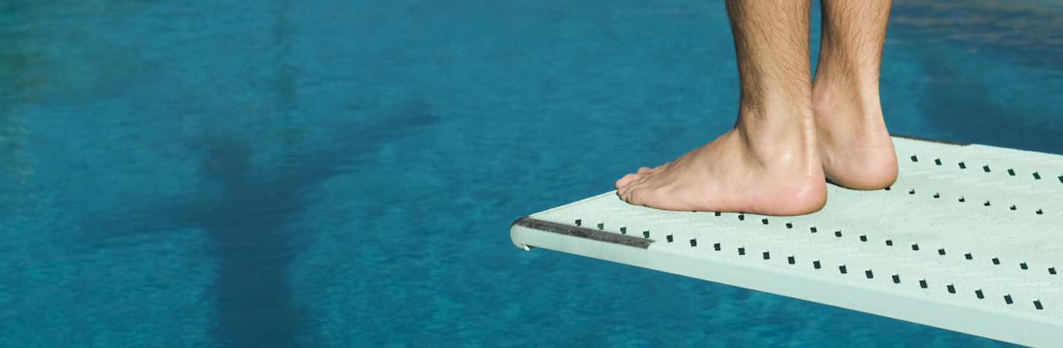

Avoiding does makes us feel better at first, but then we become more worried the next time. The more we avoid the worse it gets!

Avoiding school can mean that you lose touch with friends and the longer that goes on, the more of an issue it can become. The same applies to school-work – the more you miss, the more you might worry that you’re behind and will never catch up. (We are not worried about that, by the way – we always go back over what we’ve covered) The point is worries just get bigger when we don’t break the cycle.
Being BRAVE enough to break the pattern of avoidance is the first vital step – and we can work together to help you make it. We’ll only move at the pace you tell us you can cope with.

- Tell us about your classroom stressors so we can reduce them
If we know what triggers your anxiety in the classroom, we can let teachers know by sharing a plan with them about what to do and what not to do. For example, some pupils really worry about being asked to read aloud in front of the class, or being called on to answer a question. We can make sure this doesn’t happen.

Perhaps there is some work or some types of task you find really difficult and you worry about getting into trouble for not completing them. Again, let us know so that we can give you the help you need. Some pupils like to have a discrete way of showing the teacher that they are struggling. Maybe a planner page upturned on the desk. Again, this is something we can look at.

It might be just certain subjects that make you feel anxious, or certain teachers. Tell us so that we can help with that too. Some pupils feel much more able to cope with the classroom when they can use a time-out card – so when you feel your anxiety increase, you can escape to a safe space in school. That’s something else for us to look at.

Think about who you are sitting with in each lesson, and whereabouts in the room. Perhaps the teacher’s seating plan has created a problem for you that we need to know about. You might feel safer next to the door, so that you can use your time-out card without walking across the whole room. Or perhaps you are having to sit next to someone who makes you feel bad. You could tell us about a friend who really helps you to feel more comfortable in class and just that change of seat might make a big difference.

The more you can help us understand from your point of view, the better our advice to teachers about how to help you will be. Some simple dos and don’ts. They will all understand as they would all love to see you back with us and happy.
- Tell us about what is difficult for you outside of class
For many pupils, this is a difficult time because there isn’t so much routine or structure. Just like you did with lessons, try to think about your break and lunchtime stressors so that we can reduce them. For example, if the crowded dining hall is a problem, you could leave the lesson before lunch 5 minutes early. It might be possible for you to use your safe space at lunch, with a friend – once we have agreed where that will be. You could help out in the library. There are lots of lunchtime clubs in school so we can talk through those. Perhaps you could even start one!

If you are being bullied, you must tell us so that we can stop that.

- Talk to people you trust
Try not to keep your feelings bottled up. If there is an adult in school who you have a good relationship with and trust, we can make them part of your plan. For example, they could come to your planning meeting – or you could have some one-to-one time with them first and they could share your views at the meeting.

We could make sure that there is a check-in with your key adult at agreed times through the week, to make sure you’re okay - and also to make sure we know about what’s gone well! There will be lots of wins as you face your fears – we all want to hear about those!

Talk to your parents/carers too. The more they know about what makes you anxious, the more they will be able to bring to our meeting. Talk to a close friends so that they know that they can support you too.

- Practice breathing!
The best way to calm your anxiety is to breathe deeply – there are techniques you should practice regularly at home, when you are calm as well as when you are worried. Then use the technique in school when you feel your anxiety rising - for example, before you use your time-out pass.

You need to take strong, deep breaths that come from your belly.

- in through your nose for three
- pause
- out through your mouth for three

Try imagining that you have a hot cocoa in your hands and you’re breathing in the delicious smell through your nose for three seconds, then blowing it cool for three seconds.

Box breathing is another technique that helps lots of people. There’s a video about it here and the diagram also explains it. Picture moving around the square as you breathe:
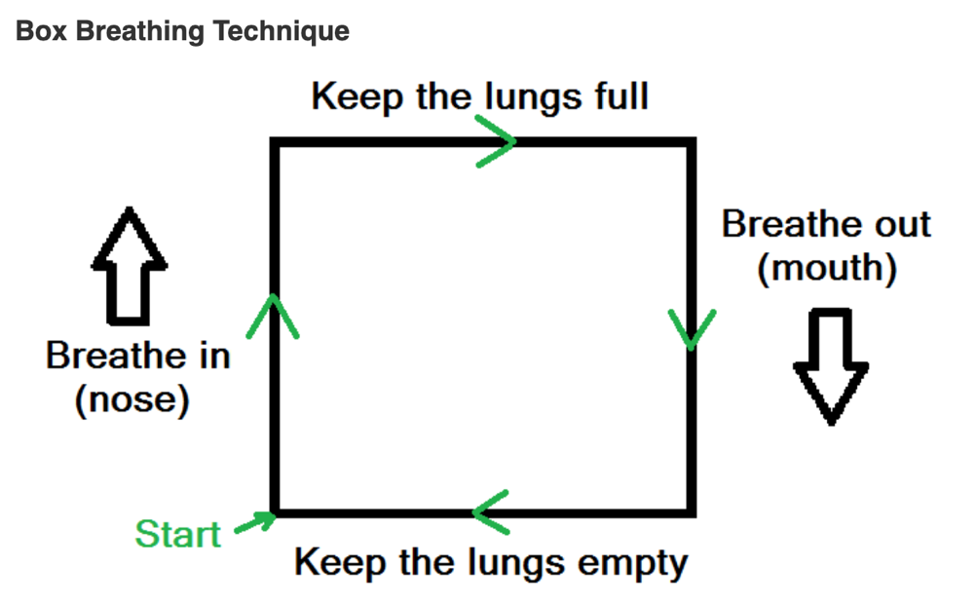

Health Minds Lincolnshire has a series of videos on different breathing techniques, here. We are all different, so it’s a good idea to spend some time finding the one that works best for you – it will then become a great friend for life!

Breathing calms your brainstem, which is the part of your brain that is causing your racing heart and mind, sweatiness, trembling or any of the other physical symptoms of anxiety. It will definitely take the edge off those sensations.
Try to build practice into your routine, at least five minutes twice a day. You’ll gradually master the skill and feel the benefits. You can then start using it in any situation that causes anxiety.

- Use relaxation techniques
Try out different relaxation techniques. There are many resources online. For example, the 30-3-30 approach introduces a wide range. You should try them out and then record which ones work for you on My Wellbeing Plan. We will be very interested to see this in school so that we know what you have found helpful and what coping skills you have developed. Muscle relaxation also relieves tension and will help you sleep. There’s a step by step guide at the end of this sheet.

- Get physical!
Some people benefit from using stress balls or fiddle toys and they find this can reduces anxiety through distraction (if the mind is occupied, it is distracted from focusing on the anxiety). You could also try other exercises such as having a cold drink, splashing your face with water. Exercise is recognised as being particularly beneficial for anxiety and low mood. Doing physical things like sport, playing football, dancing or riding a bike can help us to relax and not think about our worries. It can help us escape from thoughts and feelings.

- Eat a healthy diet
Sometimes if we have worries we can eat too much or we may not want to eat at all, which makes us more anxious. Make sure you make healthy eating part of your daily routine.

- Sleep well
It is very important to have a good sleep routine and to get enough sleep. If this is a problem, see your GP about it.

- Try to balance your thoughts
Analyse your thoughts using the balance thinking resource (below). Often it is easy for thoughts to become unbalanced and overly negative. After making a note of the thought, consider whether it is accurate and think about what evidence you may have to support or not support that thought. Try and finish with developing a more balanced/positive thought that you can write down and remember when you need to. There is a table below to help you with this.

Interested in finding out some more?

There is a lot of information online about managing anxiety, because it is a very common and normal feeling. Healthy Minds Lincolnshire have a series of YouTube clips about coping with change. If your anxiety has increased because of the changes in your life brought about by lockdown, you will find this really helpful. There are activities to complete as you listen to the videos so you’ll need paper and pens.

- For online counselling support, visit www.kooth.com
- For advice about your mental health, call the Here4You advice line: 01522 309120
- For urgent help, contact the CAMHS crisis team: 0303 123 4000

How to do progressive muscle relaxation

Progressive Muscle Relaxation teaches you how to relax your muscles through a two-step process. First, you systematically tense particular muscle groups in your body, such as your neck and shoulders. Next, you release the tension and notice how your muscles feel when you relax them. This exercise will help you to lower your overall tension and stress levels, and help you relax when you are feeling anxious. It can also help reduce physical problems such as stomach aches and headaches, as well as improve your sleep.

People with anxiety difficulties are often so tense throughout the day that they don’t even recognize what being relaxed feels like. Through practice you can learn to distinguish between the feelings of a tensed muscle and a completely relaxed muscle. Then, you can begin to “cue” this relaxed state at the first sign of the muscle tension that accompanies your feelings of anxiety. By tensing and releasing, you learn not only what relaxation feels like, but also to recognize when you are starting to get tense during the day.

Helpful hints:

- Set aside about 15 minutes to complete this exercise.
- Find a place where you can complete this exercise without being disturbed.
- For the first week or two, practise this exercise twice a day until you get the hang of it. The better you become at it, the quicker the relaxation response will “kick in” when you really need it!
- You do not need to be feeling anxious when you practise this exercise. In fact, it is better to first practice it when you are calm. That way, it will be easier to do when feeling anxious.
- Find a quiet, comfortable place to sit, then close your eyes and let your body go loose. A reclining armchair is ideal. You can lie down, but this will increase your chances of falling asleep. Although relaxing before bed can improve your sleep, the goal of this exercise is to learn to relax while awake. Wear loose, comfortable clothing, and don’t forget to remove your shoes. Take about five slow, deep breaths before you begin.

How to do it

The tension – relaxation response
Step one: Tension
The first step is applying muscle tension to a specific part of the body. This step is essentially the same regardless of which muscle group you are targeting. First, focus on the target muscle group, for example, your left hand. Next, take a slow, deep breath and squeeze the muscles as hard as you can for about 5 seconds. It is important to really feel the tension in the muscles, which may even cause a bit of discomfort or shaking. In this instance, you would be making a tight fist with your left hand.
It is easy to accidentally tense other surrounding muscles (for example, the shoulder or arm), so try to ONLY tense the muscles you are targeting. Isolating muscle groups gets easier with practice.

Be careful! Take care not to hurt yourself while tensing your muscles. You should never feel intense or shooting pain while completing this exercise. Make the muscle tension deliberate, yet gentle. If you have problems with pulled muscles, broken bones, or any medical issues that would hinder physical activity, consult your doctor first.

Step two: Relaxing the tense muscles
This step involves quickly relaxing the tensed muscles. After about 5 seconds, let all the tightness flow out of the tensed muscles. Exhale as you do this step. You should feel the muscles become loose and limp, as the tension flows out. It is important to very deliberately focus on and notice the difference between the tension and relaxation. This is the most important part of the whole exercise.

Note: It can take time to learn to relax the body and notice the difference between tension and relaxation. At first, it can feel uncomfortable to be focusing on your body, but this can become quite enjoyable over time.

Remain in this relaxed state for about 15 seconds, and then move on to the next muscle group. Repeat the tension-relaxation steps. After completing all of the muscle groups, take some time to enjoy the deep state of relaxation.

The different muscle groups
During this exercise, you will be working with almost all the major muscle groups in your body. To make it easier to remember, start with your feet and systematically move up (or if you prefer, you can do it in the reverse order, from your forehead down to your feet). For example:

- Foot (curl your toes downward)
- Lower leg and foot (tighten your calf muscle by pulling toes towards you)
- Entire leg (squeeze thigh muscles while doing above)
- (Repeat on other side of body)
- Hand (clench your fist)
- Entire right arm (tighten your biceps by drawing your forearm up towards your shoulder and “make a muscle”, while clenching fist)
- (Repeat on other side of body)
- Buttocks (tighten by pulling your buttocks together)
- Stomach (suck your stomach in)
- Chest (tighten by taking a deep breath)
- Neck and shoulders (raise your shoulders up to touch your ears)
- Mouth (open your mouth wide enough to stretch the hinges of your jaw)
- Eyes (clench your eyelids tightly shut)
- Forehead (raise your eyebrows as far as you can)

It can be helpful to listen to someone guide you through these steps. There are many relaxation CDs for sale that will take you through a progressive muscle relaxation (or something very similar). Alternatively, you can record a script of this process on a tape or CD, or ask a friend or relative with a calm, soothing voice to record it for you.

It would sound something like this:

"Take a deep breath in through your nose...hold your breath for a few seconds...and now breathe out...take another deep breath through your nose... Now pay attention to your body and how it feels.... Start with your right foot... squeeze all the muscles in your right foot. Curl your toes as tight as you can, now hold it....hold it...good...now relax and exhale...let your foot go limp...notice the difference between the tension and relaxation....feel the tension flow out of your foot like water..." (then repeat with right lower leg and foot, entire right leg, etc...)

Quick tense and relax
Once you have become familiar with the “tension and relaxation” technique, and have been practicing it for a couple weeks, you can begin to practise a very short version of progressive muscle relaxation. In this approach, you learn how to tense larger groups of muscles, which takes even less time. These muscle groups are:

- Lower limbs (feet and legs)
- Stomach and chest
- Arms, shoulders, and neck
- Face

So instead of working with just one specific muscle group at a time (e.g., your stomach), you can focus on the complete group (your stomach AND chest). You can start by focusing on your breathing during the tension and relaxation. When doing this shortened version, it can be helpful to say a certain word or phrase to yourself as you slowly exhale (such as “relax”, “let go”, “stay calm”, “peace” “it will pass” etc...). This word or phrase will become associated with a relaxed state; eventually, saying this word alone can bring on a calm feeling. This can be handy during times when it would be hard to take the time to go through all the steps of progressive muscle relaxation.

Release only
A good way to even further shorten the time you take to relax your muscles is to become familiar with the “release only” technique. One of the benefits of tensing and releasing muscles is that you learn to recognize what tense muscles feel like and what relaxed muscles feel like.

Once you feel comfortable with the tension and relaxation techniques, you can start doing “release only”, which involves removing the “tension” part of the exercise.
For example, instead of tensing your stomach and chest before relaxing them, try just relaxing the muscles. At first, the feeling of relaxation might feel less intense then when you tensed the muscles beforehand, but with practice, the release-only technique can be just as relaxing.

Final note: Remember to practise progressive muscle relaxation often, whether you are feeling anxious or not. This will make the exercise even more effective when you really do need to relax! Though it may feel a bit tedious at first, ultimately you will gain a skill that will probably become a very important part of managing your anxiety in your daily life.

Searching for evidence – balanced thinking

Thoughts – what were you thinking? | What evidence supports your thoughts? | What evidence is there that the thought is not accurate? | What is a more balanced thought? | How are you going to remember this more balanced thought when needed?
EXAMPLE  If I go to French, I will be asked to read out loud and everyone will laugh at me. | Someone laughed at me in French before | The teacher knows I get anxious and wouldn’t ask me to read out loud. Not everyone laughed at me before. | The teacher knows me and I won’t get asked to read out if I don’t want to. If I do read, someone may laugh, but not everyone. | I am going to write this at the front of my French book as a reminder

