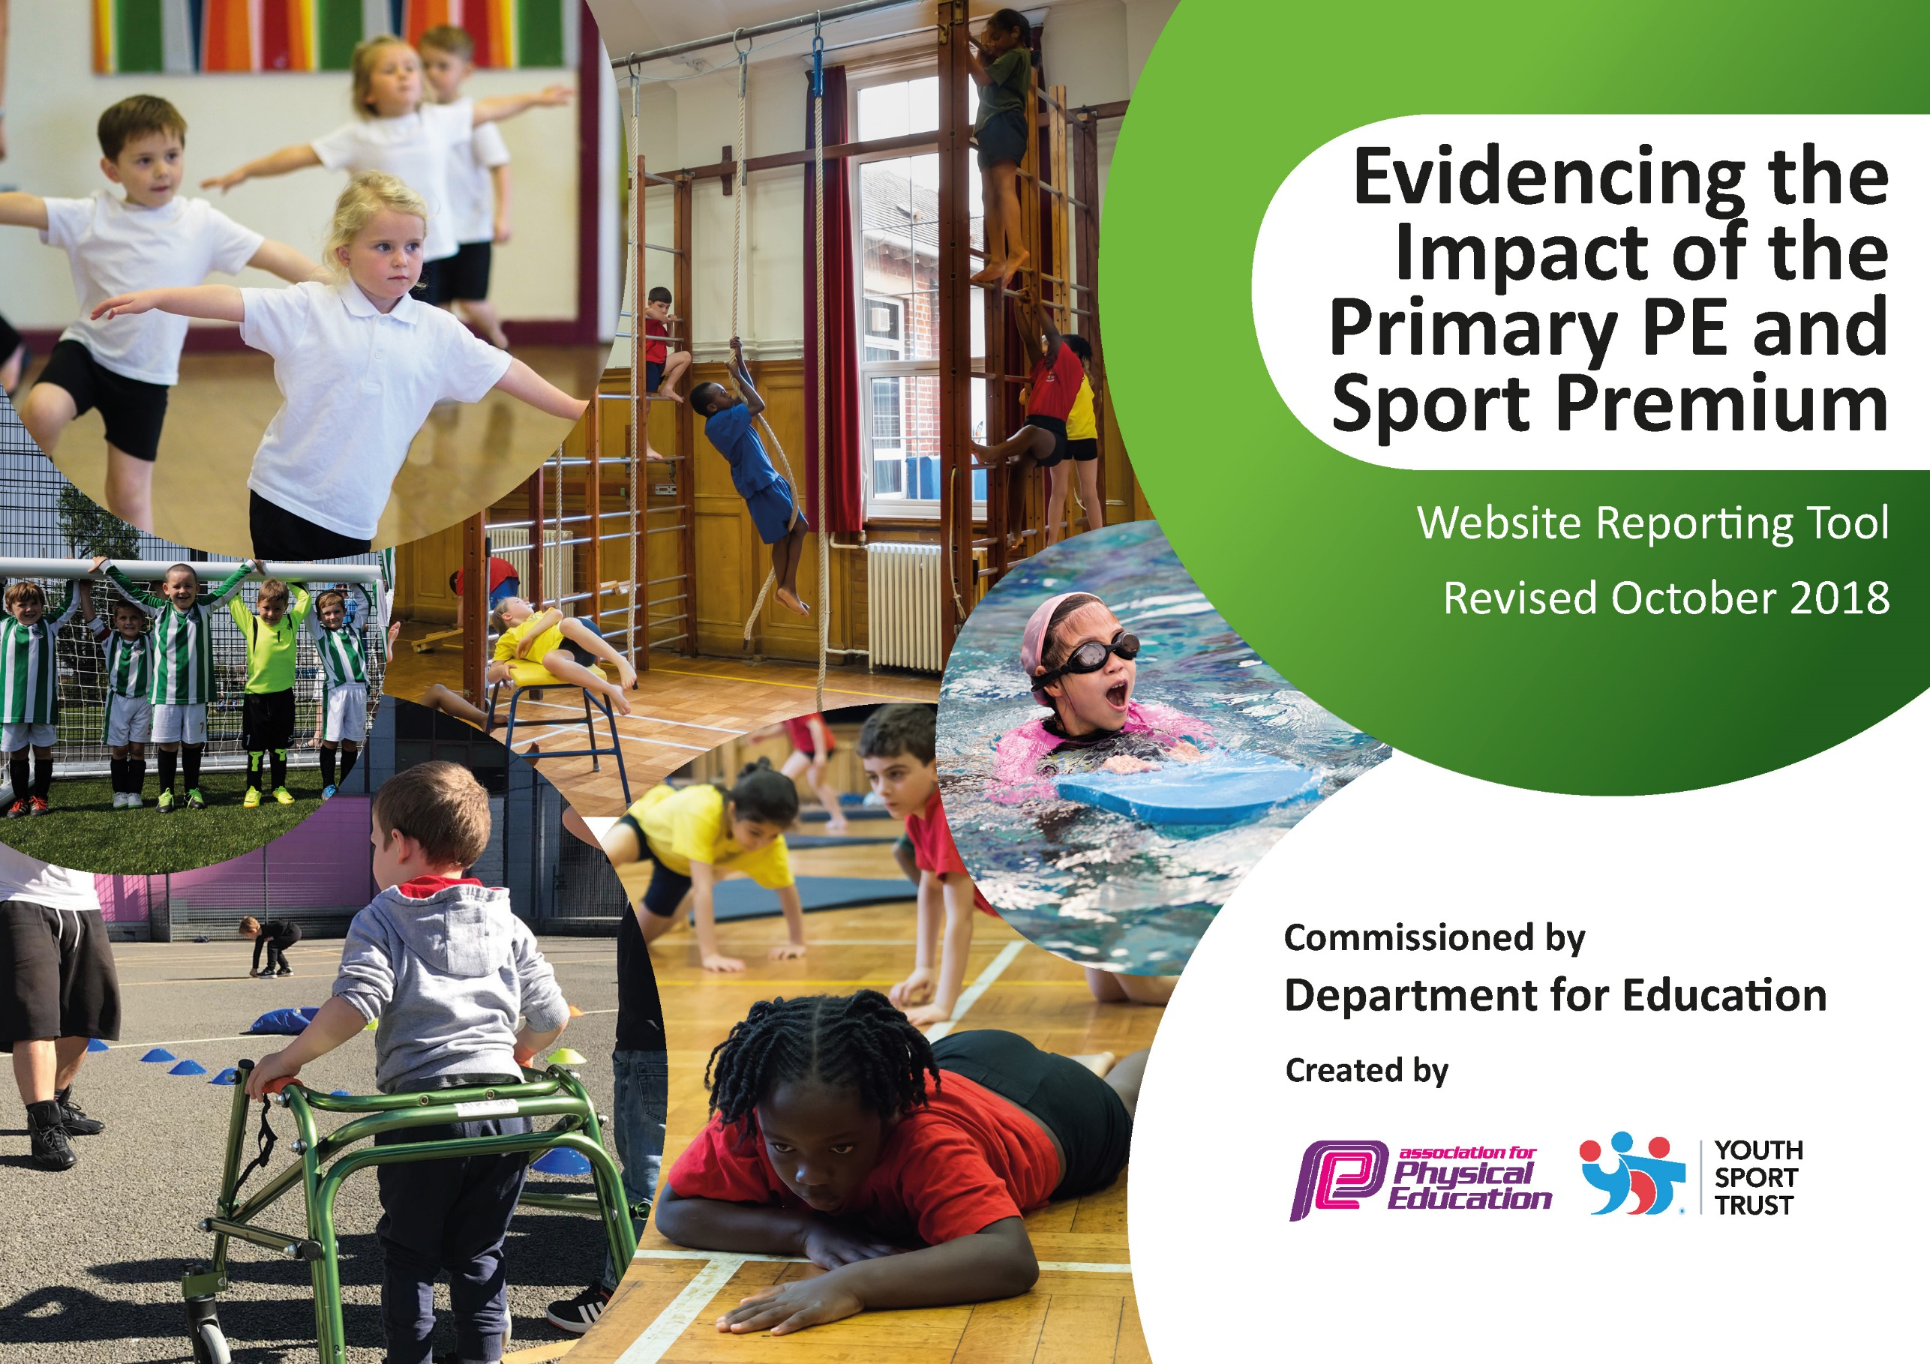
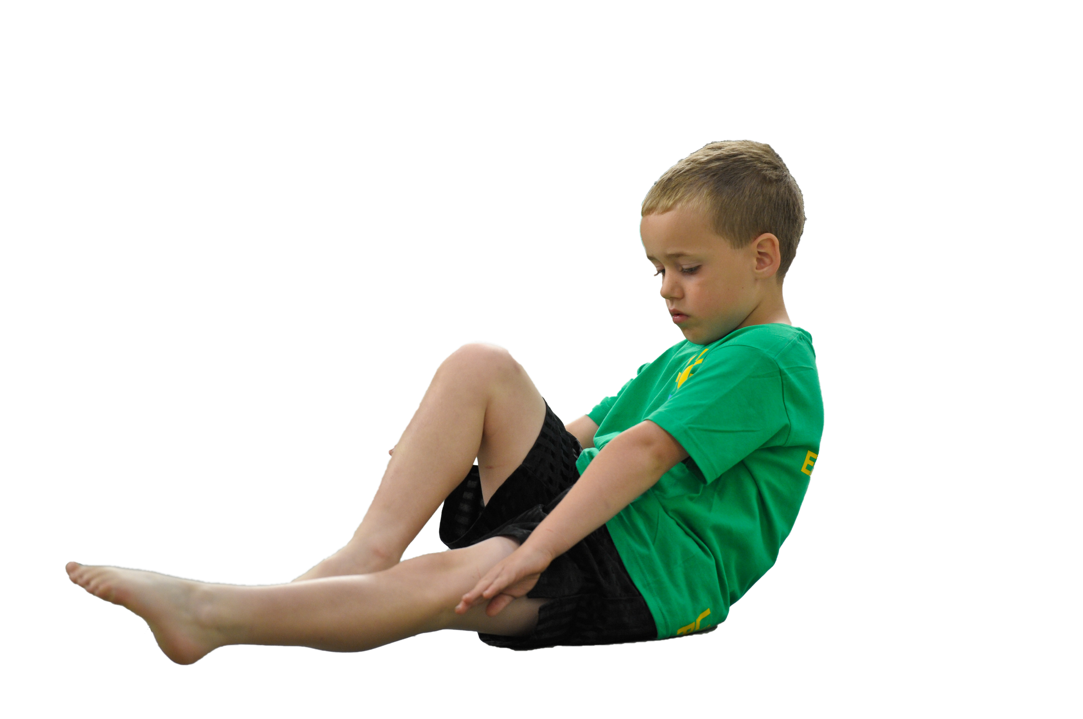
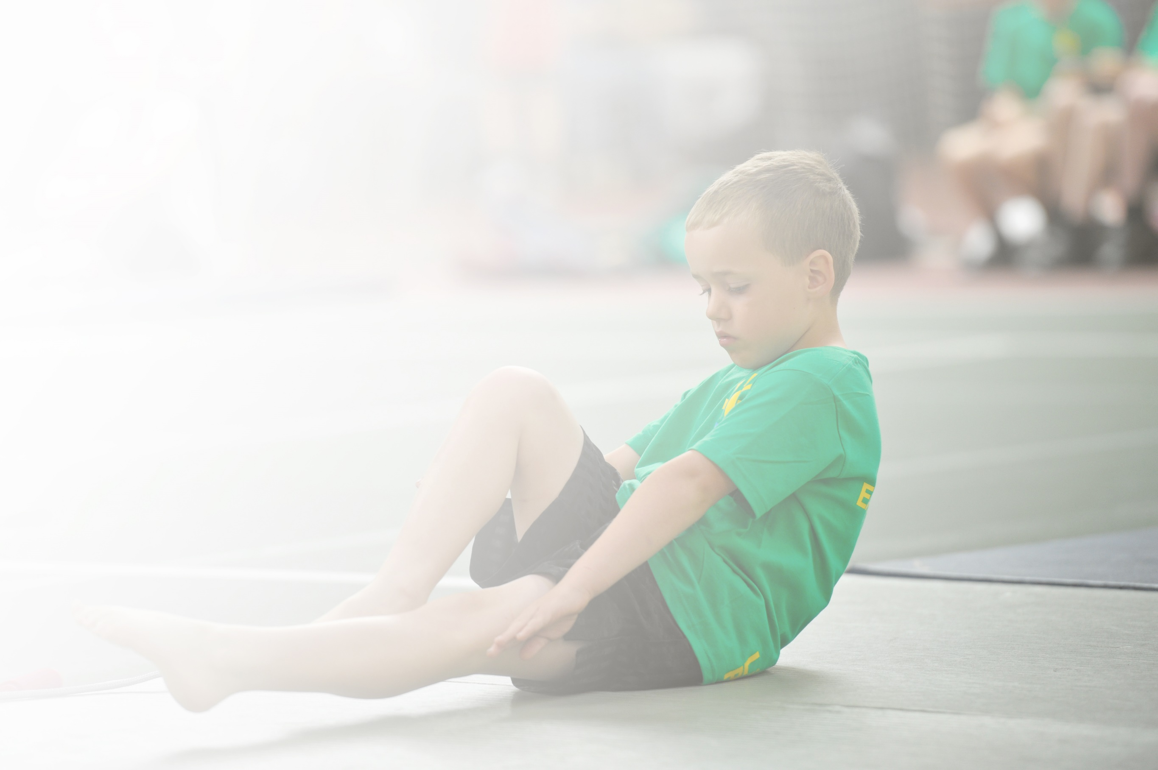
Schools must use the funding to make additional and sustainable improvements to the quality of Physical Education, Sport and Physical Activity (PESPA) they offer. This means that you should use the Primary PE and Sport Premium to:

- Develop or add to the PESPA activities that your school already offer
- Build capacity and capability within the school to ensure that improvements made now will benefit pupils joining the school in future years

Please visit gov.uk for the revised DfE guidance including the 5 key indicators across which schools should demonstrate an improvement. This document will help you to review your provision and to report
your spend. DfE encourages schools to use this template as an effective way of meeting the reporting requirements of the Primary PE and Sport Premium.

We recommend you start by reflecting on the impact of current provision and reviewing the previous
spend. Under the Ofsted Schools Inspection Framework, inspectors will assess how effectively leaders use the Primary PE and Sport Premium and measure its impact on outcomes for pupils, and how effectively governors hold them to account for this.

Schools are required to publish details of how they spend this funding as well as on the impact it has on pupils’ PE and sport participation and attainment by the end of the summer term or by 31 July 2019 at the
latest.
We recommend regularly updating the table and publishing it
on your website throughout the year, as evidence of your
ongoing review into how you are using the money to
secure maximum, sustainable impact. To see an
example of how to complete the table please
click HERE.

Support for review and reflection - considering the 5 key indicators from DfE, what development needs are a priority for your setting and your students now and why? Use the space below to reflect on previous spend, identify current need and priorities for the future.

Key achievements to date: | Areas for further improvement and baseline evidence of need:
- Pupils in Year 1 receive 2+ hours and Reception receive 1+ hours of PE per week in school.  - Many attend additional sports clubs especially in Year 1.  - A large variety of after school and lunch time clubs which have high numbers of children attending. Children that are unable to attend sports clubs are tracked and engaged though clubs and playground games during playtime, led by our sports coach and sports apprentice.  - School continues to advertise Sport Holiday Camps and hold them at Poplar Farm, which many of our children attended, on school website and signposts to wider school community via letter(s) through Parent Mail, providing our pupils with a range of sport related activities.  - By having a Sports apprentice on full time staff, more children can be engaged in physical activity through lessons and clubs.  - Inspiration through sport is becoming more common. Attendance, participation, leadership and enjoyment in school is evident. Representing and competing is improving pupil mind-sets. Sam Ruddock is set to visit and inspire the setting and set goals to achieve anything anywhere. SMSC understanding can be seen in a school and pupils can discuss their contribution to it.  - KS1 and Reception access and use of the Balance bikes to improve concentration and core development.  - PE Conference: Subject Leader attended.  - The school organised a range of specialist coaches to develop further staff skills in: Gym, Multi skills, Cricket, Real PE and Real Gym.  - Through SGO and Inspire+ school accessed a range of festivals and events for pupils of all ages so that they are introduced to new sports.  - A new trim trail has been installed to sport gross motor skills for all children. | - All children will be part of assemblies led by Sophie Allen, Sam Ruddock, Sarah Outen, Shona Macillon and Ben Smith to be inspirational for the children.  - SGO organised festivals and tournaments for our teams, – included balance bike festival and cricket. Mini Olympics for Year 1 through Inspire+ offered a good mix of intra competition.  - To continue to access Inspire+ partnership and take full advantage of the opportunities that this presents.  - Employ PE and School Sport apprentice to promote and assist with the delivery of PE and School Sport.  - Continue to raise awareness of sport and Olympics and Paralympics.  - Continue to promote all aspects of physical activity so that all pupils are physically active, through PE lesson and at play.  - Teachers understand the principles of the REAL PE scheme and feel able to utilise its strengths. Devise and implement a PE display, in hall highlighting the multi ability cogs that we are aiming to improve.  - Continued access to sports and events through SGO and Inspire+. KS1 emphasis if possible in 2019/20.  - Prepare for the teaching of swimming with a focus on life saving skills.

Meeting national curriculum requirements for swimming and water safety | Please complete all of the below:
What percentage of your current Year 6 cohort swim competently, confidently and proficiently over a distance of at least 25 metres?  N.B. Even though your children may swim in another year please report on their attainment on leaving  primary school. | N/A
What percentage of your current Year 6 cohort use a range of strokes effectively [for example, front crawl, backstroke and breaststroke]? | N/A
What percentage of your current Year 6 cohort perform safe self-rescue in different water-based situations? | N/A
Schools can choose to use the Primary PE and Sport Premium to provide additional provision for swimming but this must be for activity over and above the national curriculum requirements. Have you used it in this way? | No

Action Plan and Budget Tracking
Capture your intended annual spend against the 5 key indicators. Clarify the success criteria and evidence of impact that you intend to measure to evaluate for students today and for the future.

Academic Year: 2019/20 | Total fund allocated: £16,440 | Date Updated: Sept 2019
Key indicator 1: The engagement of all pupils in regular physical activity – Chief Medical Officer guidelines recommend that primary school children undertake at least 30 minutes of physical activity a day in school |  |  |  | Percentage of total allocation:
 |  |  |  | 58%
School focus with clarity on intended impact on pupils: | Actions to achieve: | Funding allocated: | Evidence and impact: | Sustainability and suggested next steps:
Promote healthy active lifestyles amongst all children.  Raise mental health/wellbeing awareness.  Use Physical Activity to promote learning across the curriculum | To improve the amount of physical activity carried out by all children in our school as part of our commitment to promoting healthy, active lifestyles.  Healthy ME week during the summer term.  Employ a PE and School Sport Apprentice.  Inspire + Ambassadors to attend school throughout the year Sam Ruddock, Shona McCallin, Sophie Allen and Ben Smith.  To increase awareness amongst both children and staff about the importance of mental health and well-being.  To raise awareness of the importance of healthy eating.  To introduce the Daily Mile for all children in school. | Inspire + membership - £3000  PE apprentice -  £6,531.42 | Inspire+ Impact reports.  Monitor children making use of playground games.
Key indicator 2: The profile of PESSPA being raised across the school as a tool for whole school improvement |  |  |  | Percentage of total allocation:
 |  |  |  | 0%
School focus with clarity on intended impact on pupils: | Actions to achieve: | Funding allocated: | Evidence and impact: | Sustainability and suggested next steps:
Regular opportunities for children to engage in sport and physical activity. | To engage children and staff in physical activities.  Healthy Me week and intra sport competitions using house system.  Purchase and implement the Balance ability Programme for children in YR and Y1.  Use mentors to help use sport as a way to motivate children who are not fully engaged with their learning. |  | Newsletters, website, noticeboard.  Whole school assemblies.  Pupil Interviews

Key indicator 3: Increased confidence, knowledge and skills of all staff in teaching PE and sport |  |  |  | Percentage of total allocation:
 |  |  |  | 12%
School focus with clarity on intended  impact on pupils: | Actions to achieve: | Funding  allocated: | Evidence and impact: | Sustainability and suggested  next steps:
Improved teaching of PE across the curriculum | Opportunity for staff to Team Teach with sports coach from Inspire+.  Staff to take advantage of the CPD offered through our Inspire+ membership.  PE Apprentice to support the delivery of PE and School Sport. | Sports coaching  £1950 | Lesson observations.  Pupil interviews.  Staff rag rate coaching.  Assessment data using REAL PE resources.
Key indicator 4: Broader experience of a range of sports and activities offered to all pupils |  |  |  | Percentage of total allocation:
 |  |  |  | 0%
School focus with clarity on intended  impact on pupils: | Actions to achieve: | Funding  allocated: | Evidence and impact: | Sustainability and suggested  next steps:
Additional achievements:  To provide children with a wide variety of extra-curricular clubs. | To pay coaches from Inspire + to teach lessons and clubs for children from all year groups. Multi skills, gymnastics KS2, Boxercise and football.  Continue to develop relationships with external clubs and organisations (Chance to Shine, Grantham CC, Grantham Table Tennis Club etc)  Year 1 to attend Mini Olympics.  Purchase Balance Bikes for children in YR and Y1 to use. | Sport coaching | Pupil Participation Tracker  Pupil/staff interviews.
Key indicator 5: Increased participation in competitive sport |  |  |  | Percentage of total allocation:
 |  |  |  | 30%
School focus with clarity on intended  impact on pupils: | Actions to achieve: | Funding  allocated: | Evidence and impact: | Sustainability and suggested  next steps:
To provide regular opportunities for our children to compete in both intra school and inter school competitions. | Contribute towards the local SGO and ensure that we enter as many competitions as possible using as many children as we can.  School to provide Intra school competitions on a termly basis.  Buy resources for the school, such as balance bikes, gym equipment etc. | Resources  £4958.58 | Attendance at Sports competitions

